TO GET POINTS WHERE TO PUT POINTS OF CRASHES WHEN CLICKING ON "SHOW" BUTTON INSIDE POINT OF CONCENTRATION WINDOW

<server>/concentration

params:

year - the year 2017- 2019

id - id of the point of concentration

return:

JSON array of Points

JSON Point:

date - date of accident (string)

id - id of accident (int)

type - type of accident (string)

lng - longitude (float)

ltd - latitude (float)

TO GET ALL INFO ABOUT AN ACCIDENT (IF NEEDED)

<server>/accidents/exact

params:

year - year of accident

id - id of accident

return:

JSON with accident info

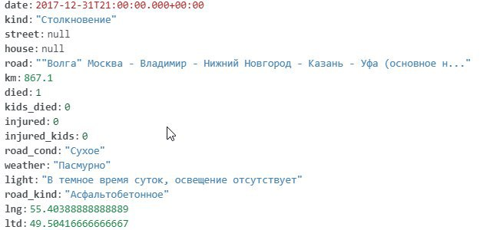

TO GET ALL POINTS OF CONCENTRATION

<server>/points

params:

year - year u know

return:

JSON of Points of concentration

JSON Points of concentration

fields:

id - id of a point

crashes - array of crash id`s

lng - longitude

ltd – latitude

TO GET ALL POINTS OF ACCIDENTS

<server>/accidents

params:

year - a year

return:

JSON array of Points